October 2025
At Cefn Glas Infants we achieved our SILVER award in 2023
We are very excited to announce that we are currently working towards our GOLD Award!
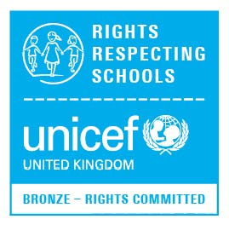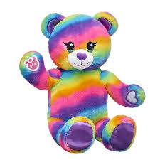
Unicef UK Rights Respecting School
‘Unicef is the world’s leading organisation working for children and young people and their rights. In 1989, governments across the world agreed that all children have the same rights by adopting the UN Convention on the Rights of the Child (UNCRC) These rights are based on what a child needs to survive, grow, participate and fulfil their potential. Our pupils will learn about their rights by putting them into practice every day. A Rights Respecting School models rights and respect in all it’s relationships.’

We have our very own mascot named Rainbow Rights who helps us learn about our rights in school and at home. Our RRS Ambassadors for 2025/2026 have been voted in by their class mates, they will help Rainbow Rights to spread the message that ‘We’ve All Got Rights’

You may find these links useful for more information
https://www.unicef.org.uk

https://youtu.be/Fk4j2cMJzCQ
Remember to keep checking on our parent app for the school
ARTICLE of the MONTH

